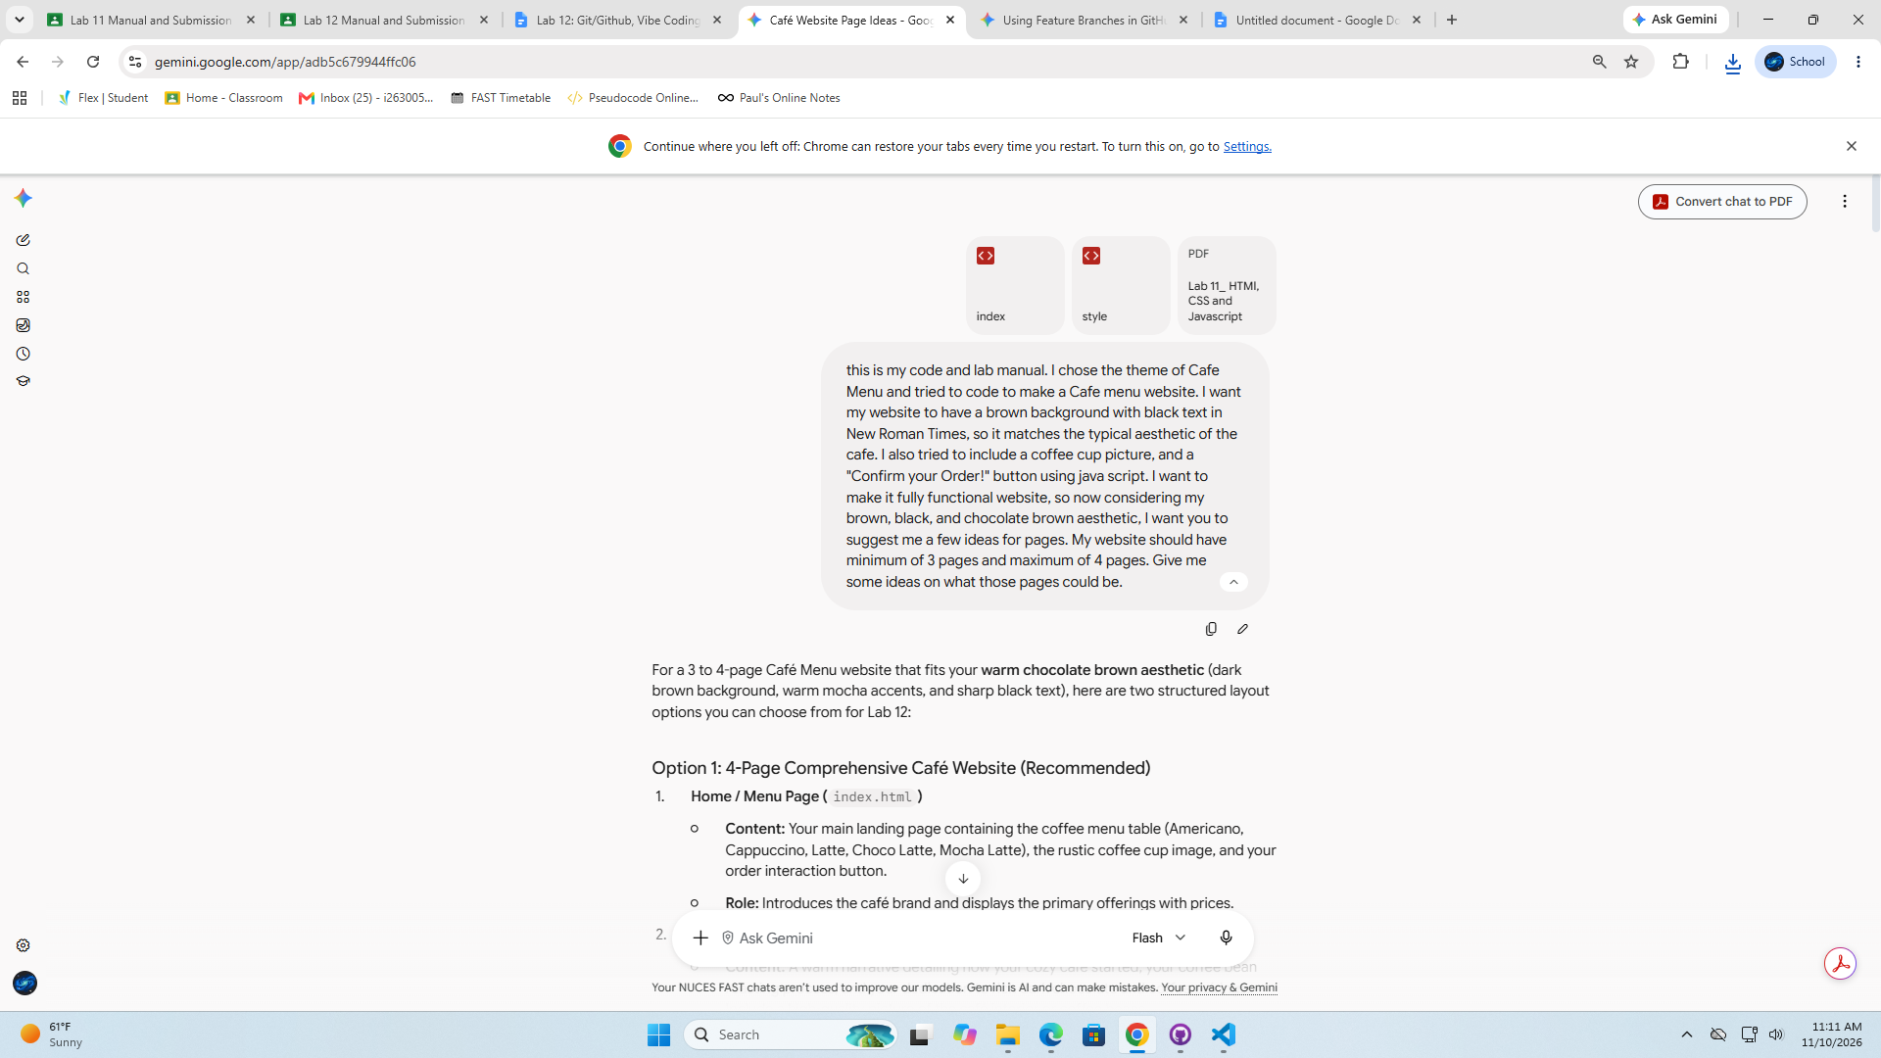

this is my code and lab manual. I chose the theme of Cafe Menu and tried to code to make a Cafe menu website. I want my website to have a brown background with black text in New Roman Times, so it matches the typical aesthetic of the cafe. I also tried to include a coffee cup picture, and a "Confirm your Order!" button using java script. I want to make it fully functional website, so now considering my brown, black, and chocolate brown aesthetic, I want you to suggest me a few ideas for pages. My website should have minimum of 3 pages and maximum of 4 pages. Give me some ideas on what those pages could be.

For a 3 to 4-page Café Menu website that fits your warm chocolate brown aesthetic (dark brown background, warm mocha accents, and sharp black text), here are two structured layout options you can choose from for Lab 12:

Option 1: 4-Page Comprehensive Café Website (Recommended)
- Home / Menu Page (index.html)

  - Content: Your main landing page containing the coffee menu table (Americano, Cappuccino, Latte, Choco Latte, Mocha Latte), the rustic coffee cup image, and your order interaction button.

  - Role: Introduces the café brand and displays the primary offerings with prices.

- About Us / Our Story (about.html)

  - Content: A warm narrative detailing how your cozy café started, your coffee bean roasting process, and your dedication to rich dark chocolate and coffee pairings. Include a high-quality picture of the café interior or coffee beans.

  - Role: Adds depth to your café's identity while maintaining the warm vintage layout.

- Specialties & Bakery (specials.html)

  - Content: A supplementary menu table showcasing freshly baked goods that pair with your coffee (e.g., Chocolate Lava Cake, Cinnamon Rolls, Warm Brownies, Espresso Donuts) along with their prices and dietary tags (e.g., Vegan, Nut-Free).

  - Role: Expands your food catalog beyond just hot beverages.

- Contact & Location (contact.html)

  - Content: Opening hours (e.g., 8:00 AM – 10:00 PM), street address, phone number, and a simple HTML feedback/reservation contact form with an interactive "Send Message" button.

  - Role: Gives your visitors practical business details and another place to use JavaScript interactivity.

Option 2: 3-Page Streamlined Café Website
- Home & Menu (index.html)

  - Content: Your existing main page with the primary drinks list, coffee cup image, and "Confirm your Order!" feature.

- Our Café Story (about.html)

  - Content: A brief history of your coffee shop, your sourcing philosophy for chocolate and beans, and photos of your cozy seating area.

- Visit & Contact (contact.html)

  - Content: Café address, business hours, seating availability, and a contact/feedback form for customer inquiries.

Which option fits your vision best? If you'd like, I can help you write the code for any of these pages or show you how to link them together using a navigation bar.

okay, I like your option 2. Generate code for each of the page. Remember to keep my aesthetic of the light taupe #B38B6D for the background, Chocolate brown #411900 for text color and Ding Dong Handwritten Font for the text, the lining of the table should be of Black colour. Also try to add some aesthetic photos in my website. The phots should feel natural, rather than forced and the placement of the images should not feel awkward.

Here is the complete multi-page code for your Café website built to meet your aesthetic and lab requirements.

Aesthetic Palette & Settings Used
- Background Color: Light Taupe (#B38B6D)

- Text & Heading Color: Chocolate Brown (#411900)

- Table Borders: Solid Black (#000000)

- Font Family: 'Ding Dong', 'Times New Roman', serif (with fallback to Google Fonts' handwritten styles if local font isn't installed)

- Photos: High-quality Unsplash coffee aesthetic photos curated for natural integration into cards and banners.

File Structure
Keep all files in the same project folder:

Plaintext
cafe_website/
├── index.html
├── about.html
├── contact.html
└── style.css

1. style.css (Shared Stylesheet)
CSS
@import url('https://fonts.googleapis.com/css2?family=Caveat:wght@600&family=Playfair+Display:ital,wght@0,600;1,400&display=swap');

/* Main Aesthetic Settings */
body {
background-color: #B38B6D;
color: #411900;
font-family: 'Ding Dong', 'Caveat', 'Times New Roman', serif;
font-size: 20px;
margin: 0;
padding: 0;
line-height: 1.6;
}

/* Header & Navigation */
header {
text-align: center;
padding: 25px 10px 15px 10px;
background-color: rgba(65, 25, 0, 0.08);
border-bottom: 2px solid #411900;
}

h1, h2, h3 {
font-family: 'Ding Dong', 'Playfair Display', 'Times New Roman', serif;
color: #411900;
text-align: center;
margin-top: 10px;
}

h1 {
font-size: 2.8rem;
margin-bottom: 5px;
}

nav {
margin-top: 15px;
}

nav a {
color: #411900;
text-decoration: none;
font-weight: bold;
font-size: 1.3rem;
margin: 0 15px;
padding: 5px 12px;
border: 1px solid dashed #411900;
border-radius: 15px;
transition: all 0.3s ease;
}

nav a:hover {
background-color: #411900;
color: #B38B6D;
}

/* Main Container Layout */
.container {
max-width: 900px;
margin: 30px auto;
padding: 0 20px;
}

/* Table Styling */
table {
width: 100%;
border-collapse: collapse;
margin: 25px 0;
font-family: 'Ding Dong', 'Times New Roman', serif;
font-size: 1.2rem;
background-color: rgba(255, 255, 255, 0.15);
}

table, th, td {
border: 2px solid #000000; /* Black borders per requirement */
}

th, td {
padding: 12px 15px;
text-align: center;
color: #411900;
}

th {
background-color: rgba(65, 25, 0, 0.15);
font-size: 1.3rem;
}

/* Buttons */
.btn-container {
text-align: center;
margin: 25px 0;
}

button, .submit-btn {
background-color: #411900;
color: #B38B6D;
font-family: 'Ding Dong', 'Times New Roman', serif;
font-size: 1.2rem;
padding: 10px 25px;
border: 2px solid #000000;
border-radius: 20px;
cursor: pointer;
transition: background-color 0.2s ease, transform 0.1s ease;
}

button:hover, .submit-btn:hover {
background-color: #2b1000;
transform: scale(1.03);
}

/* Aesthetic Image Layouts */
.hero-image {
width: 100%;
max-height: 380px;
object-fit: cover;
border-radius: 12px;
border: 2px solid #411900;
margin: 20px 0;
box-shadow: 0 4px 10px rgba(0,0,0,0.15);
}

.grid-2col {
display: flex;
gap: 25px;
align-items: center;
margin: 30px 0;
flex-wrap: wrap;
}

.grid-2col img {
width: 45%;
min-width: 280px;
height: 280px;
object-fit: cover;
border-radius: 12px;
border: 2px solid #411900;
}

.grid-2col .text-box {
flex: 1;
min-width: 280px;
}

/* Forms */
.contact-form {
display: flex;
flex-direction: column;
gap: 15px;
max-width: 500px;
margin: 0 auto;
}

.contact-form input, .contact-form textarea {
font-family: 'Ding Dong', 'Times New Roman', serif;
font-size: 1.1rem;
padding: 10px;
border: 2px solid #411900;
border-radius: 8px;
background-color: rgba(255, 255, 255, 0.4);
color: #411900;
}

footer {
text-align: center;
padding: 20px;
margin-top: 40px;
border-top: 1px solid #411900;
font-size: 1rem;
}

2. index.html (Home & Menu Page)
HTML
<!-- Sara Parvez, 26I-3005, Cafe Menu -->
<!DOCTYPE html>
<html lang="en">
<head>
<meta charset="UTF-8">
<link rel="stylesheet" href="style.css">
<title>Warm Roast Café - Menu</title>
</head>
<body>

<header>
<h1>Warm Roast Café</h1>
<nav>
<a href="index.html">Menu</a>
<a href="about.html">Our Story</a>
<a href="contact.html">Visit Us</a>
</nav>
</header>

<div class="container">
<h2>Handcrafted Brews & Coffee</h2>

<img src="https://images.unsplash.com/photo-1509042239860-f550ce710b93?q=80&w=1000&auto=format&fit=crop"
alt="Cozy Coffee Cup"
class="hero-image">

<table>
<tr>
<th>Type of Coffee</th>
<th>Price ($)</th>
</tr>
<tr>
<td>Americano</td>
<td>3.00</td>
</tr>
<tr>
<td>Cappuccino</td>
<td>3.20</td>
</tr>
<tr>
<td>Coffee Latte</td>
<td>4.20</td>
</tr>
<tr>
<td>Choco Latte</td>
<td>5.00</td>
</tr>
<tr>
<td>Mocha Latte</td>
<td>4.50</td>
</tr>
</table>

<div class="btn-container">
<button type="button" onclick="confirmOrder()">Confirm your Order!</button>
</div>
</div>

<footer>
<p>&copy; Warm Roast Café. Crafted with warmth & cocoa.</p>
</footer>

<script>
function confirmOrder() {
console.log("Order button was clicked by the user.");
window.alert("Your warm cup of coffee has been confirmed! We are preparing it with care.");
}
</script>
</body>
</html>

3. about.html (Our Story Page)
HTML
<!-- Sara Parvez, 26I-3005, Cafe Story -->
<!DOCTYPE html>
<html lang="en">
<head>
<meta charset="UTF-8">
<link rel="stylesheet" href="style.css">
<title>Warm Roast Café - Our Story</title>
</head>
<body>

<header>
<h1>Warm Roast Café</h1>
<nav>
<a href="index.html">Menu</a>
<a href="about.html">Our Story</a>
<a href="contact.html">Visit Us</a>
</nav>
</header>

<div class="container">
<h2>About Our Sanctuary</h2>

<div class="grid-2col">
<img src="https://images.unsplash.com/photo-1442512595331-e89e73853f31?q=80&w=800&auto=format&fit=crop"
alt="Freshly roasted coffee beans">
<div class="text-box">
<h3>Ethically Sourced Beans</h3>
<p>Founded with a passion for slow mornings and rich dark chocolate accents, Warm Roast Café blends traditional espresso brewing with authentic single-origin cocoa beans.</p>
</div>
</div>

<div class="grid-2col">
<div class="text-box">
<h3>A Cozy Haven</h3>
<p>We built our space for thinkers, readers, and coffee purists alike. Every corner of our café reflects warm taupe woods, dark cocoa notes, and ambient comfort.</p>
</div>
<img src="https://images.unsplash.com/photo-1554118811-1e0d58224f24?q=80&w=800&auto=format&fit=crop"
alt="Cozy interior seating area">
</div>
</div>

<footer>
<p>&copy; Warm Roast Café. Crafted with warmth & cocoa.</p>
</footer>

</body>
</html>

4. contact.html (Visit & Contact Page)
HTML
<!-- Sara Parvez, 26I-3005, Cafe Contact -->
<!DOCTYPE html>
<html lang="en">
<head>
<meta charset="UTF-8">
<link rel="stylesheet" href="style.css">
<title>Warm Roast Café - Visit Us</title>
</head>
<body>

<header>
<h1>Warm Roast Café</h1>
<nav>
<a href="index.html">Menu</a>
<a href="about.html">Our Story</a>
<a href="contact.html">Visit Us</a>
</nav>
</header>

<div class="container">
<h2>Hours & Location</h2>

<table>
<tr>
<th>Day</th>
<th>Opening Hours</th>
</tr>
<tr>
<td>Monday – Friday</td>
<td>7:30 AM – 9:00 PM</td>
</tr>
<tr>
<td>Saturday – Sunday</td>
<td>8:30 AM – 10:30 PM</td>
</tr>
</table>

<h2>Reserve a Table or Leave a Note</h2>

<form class="contact-form" onsubmit="event.preventDefault(); submitFeedback();">
<input type="text" id="name" placeholder="Your Name" required>
<input type="email" id="email" placeholder="Your Email Address" required>
<textarea id="message" rows="4" placeholder="Your Message or Special Request..." required></textarea>
<button type="submit" class="submit-btn">Send Message</button>
</form>
</div>

<footer>
<p>&copy; Warm Roast Café. Crafted with warmth & cocoa.</p>
</footer>

<script>
function submitFeedback() {
var userName = document.getElementById('name').value;
console.log("Feedback received from: " + userName);
window.alert("Thank you, " + userName + "! We have received your note and look forward to hosting you.");
}
</script>
</body>
</html>

Key Features Implemented:
- Lab Requirements: Correct HTML structural markup, external CSS linking, inline JavaScript alert pop-ups (window.alert), developer logging (console.log), and lab header comment blocks (Name, Roll Number, Section).

- Table Design: Tables use explicit 2px solid black borders (#000000) styled via CSS while keeping full color alignment across pages.

- Natural Photo Integration: Replaced isolated right-floated images with balanced full-width hero containers and alternating two-column text/photo cards.

last page "Visit Us", there was no mentioned of the contact. Can you add the contact us code on that last page. "Contact: Sara Parvez via i263005@isb.nu.edu.pk"

Here is the updated contact.html page code with your contact details neatly integrated above the feedback form, matching the rest of your brown and dark cocoa design.

Updated contact.html
HTML
<!-- Sara Parvez, 26I-3005, Cafe Contact -->
<!DOCTYPE html>
<html lang="en">
<head>
<meta charset="UTF-8">
<link rel="stylesheet" href="style.css">
<title>Warm Roast Café - Visit Us</title>
</head>
<body>

<header>
<h1>Warm Roast Café</h1>
<nav>
<a href="index.html">Menu</a>
<a href="about.html">Our Story</a>
<a href="contact.html">Visit Us</a>
</nav>
</header>

<div class="container">
<h2>Hours & Location</h2>

<table>
<tr>
<th>Day</th>
<th>Opening Hours</th>
</tr>
<tr>
<td>Monday – Friday</td>
<td>7:30 AM – 9:00 PM</td>
</tr>
<tr>
<td>Saturday – Sunday</td>
<td>8:30 AM – 10:30 PM</td>
</tr>
</table>

<h2>Contact Us</h2>
<div class="text-box" style="text-align: center; margin-bottom: 25px;">
<p>For inquiries, catering, or table bookings, reach out directly to:</p>
<p><strong>Sara Parvez</strong>: <a href="mailto:i263005@isb.nu.edu.pk" style="color: #411900; text-decoration: underline;">i263005@isb.nu.edu.pk</a></p>
</div>

<h2>Reserve a Table or Leave a Note</h2>

<form class="contact-form" onsubmit="event.preventDefault(); submitFeedback();">
<input type="text" id="name" placeholder="Your Name" required>
<input type="email" id="email" placeholder="Your Email Address" required>
<textarea id="message" rows="4" placeholder="Your Message or Special Request..." required></textarea>
<button type="submit" class="submit-btn">Send Message</button>
</form>
</div>

<footer>
<p>&copy; Warm Roast Café. Crafted with warmth & cocoa.</p>
</footer>

<script>
function submitFeedback() {
var userName = document.getElementById('name').value;
console.log("Feedback received from: " + userName);
window.alert("Thank you, " + userName + "! We have received your note and look forward to hosting you.");
}
</script>
</body>
</html>

